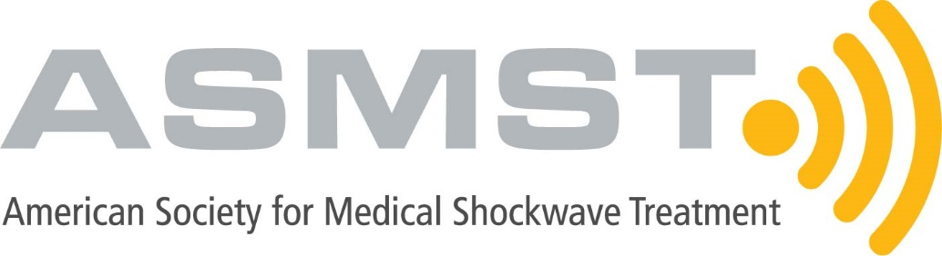

FOR IMMEDIATE RELEASE

Contact:
Lauren Zuber
413.686.9180
lauren@markens.com

ASMST’s First Annual Summit Brings Together International Leaders to Shape the Future of Shockwave Medicine

SPRINGFIELD, MA, March 25, 2025 – The American Society for Medical Shockwave Treatment (ASMST) successfully hosted its first Annual Summit, bringing together over 150 attendees, including leading experts from around the world, to advance Extracorporeal Shockwave Therapy (ESWT). Clinicians, researchers, and industry pioneers gathered in Boston, Massachusetts, to present groundbreaking research, refine best practices, and explore new frontiers in regenerative medicine, orthopedics, and sports rehabilitation. The summit featured cutting-edge scientific discussions, hands-on training, and the latest industry innovations, solidifying ESWT’s growing role in modern healthcare.
“This Summit was a defining moment for shockwave medicine, bringing together the world’s top experts to shape the future of ESWT,” said Dr. Brice Blatz, ASMST President. “The research, discussions, and hands-on training delivered here will have a lasting impact on how shockwave therapy is integrated into clinical practice and rehabilitation strategies worldwide.”
ASMST’s founding sponsors—Enovis, SoftWave, and STORZ Medical—played a pivotal role in the success of the inaugural Summit. The industry leaders showcased next-generation focused and radial shockwave devices, EMTT technologies, and other cutting-edge regenerative solutions, expanding the possibilities of ESWT. Their innovations are pushing the boundaries of non-invasive therapies and redefining patient care across multiple medical disciplines.

Throughout the two-day Summit, attendees engaged in discussions on expanding ESWT applications, its integration with orthobiologic treatments, and its role in advanced rehabilitation protocols. The program featured global trailblazers in shockwave medicine, including International Society for Medical Shockwave Treatment (ISMST) leaders, Prof. Dr. Ludger Gerdesmeyer, Prof. Dr. Karsten Knobloch, Prof. Dr. Carlos Leal, and Prof. Dr. Wolfgang Schaden, each of whom provided expert insights into the evolving landscape of shockwave therapy.
Prof. Dr. Carlos Leal, ISMST Scientific Secretary, presented breakthrough research on ESWT’s role in severe knee osteoarthritis (OA), demonstrating its ability to reduce pain, improve function, and serve as a non-surgical alternative for patients who are not candidates for total knee replacement. His findings highlighted ESWT’s potential for cartilage regeneration, subchondral bone stimulation, and inflammation reduction, reinforcing its importance as a minimally invasive solution for chronic OA management.
Prof. Dr. Ludger Gerdesmeyer, ISMST Business Coordinator, explored ESWT’s expanding role in tissue engineering, emphasizing its multimodal applications in orthobiologic treatments, exercise therapy, and electromagnetic transduction technologies. His work detailed the biomechanical and biochemical mechanisms behind ESWT and its integration with Extracorporeal Magnetic Transduction Therapy (EMTT), offering promising advancements in tissue healing and pain management.
Prof. Dr. Wolfgang Schaden, ISMST President and a pioneer in shockwave medicine, provided insight into the historical evolution and expanding applications of ESWT. His presentation underscored how shockwave therapy is transforming multiple fields of medicine, from wound healing and musculoskeletal conditions to urology and neurological disorders, marking a significant shift in non-invasive treatment strategies.
Prof. Dr. Karsten Knobloch, ISMST Vice President and a leading researcher in shockwave therapy for tendinopathy and soft tissue healing, presented the latest findings on ESWT’s effectiveness in treating Achilles tendinopathy, plantar fasciitis, and lateral epicondylitis. His research confirmed that shockwave therapy enhances tendon regeneration, improves vascularization, and accelerates functional recovery, reinforcing its superiority over traditional treatment modalities.
Dr. Amol Saxena presented compelling evidence on the integration of ESWT in surgical recovery, showing that patients who received post-operative ESWT had faster return-to-activity timelines and better functional outcomes compared to those who underwent surgery alone. His research emphasized that shockwave therapy significantly enhances post-surgical healing for Achilles tendinopathy, osteotomies, fusions, and fractures. Additionally, Dr. HC Rhim provided a comprehensive review of the top ESWT research articles of 2024 and 2025, highlighting key advancements in shockwave therapy for plantar fasciitis, knee osteoarthritis, rotator cuff injuries, and sports medicine applications. His session emphasized the growing body of evidence supporting ESWT as a first-line treatment for musculoskeletal conditions and the need for standardization in treatment protocols​.
Dr. Jennifer Soo Hoo presented findings from an international modified Delphi study, which established expert consensus recommendations on ESWT best practices, terminology, and clinical indications. Her work provided valuable guidelines for standardizing shockwave therapy applications across sports medicine and musculoskeletal care, ensuring consistency and effectiveness in clinical practice worldwide​.
In the field of sports medicine, Dr. Joshua Goldman discussed ESWT’s increasing adoption in elite athlete recovery, demonstrating its ability to accelerate healing for bone marrow edema, tendinopathies, and post-surgical rehabilitation. Dr. Jay Spector followed with an in-depth analysis of shockwave therapy’s applications in teenage athletes, outlining best practices for injury prevention and treatment personalization based on growth patterns and musculoskeletal development.
Dr. Adam Tenforde led a discussion on the importance of outcome measures in ESWT, emphasizing the need for tracking functional recovery, pain reduction, and patient-reported outcomes to refine treatment protocols. His session provided attendees with evidence-based strategies for optimizing ESWT’s long-term benefits in both clinical and athletic settings.
The Summit also addressed shockwave therapy’s role in military medicine, with Dr. Jenny Yuan sharing research from the Musculoskeletal Injury Rehabilitation Research for Operational Readiness (MIRROR) program. Her findings highlighted ESWT’s effectiveness in treating musculoskeletal injuries among active-duty service members, improving recovery times and enhancing operational readiness.
Dr. Joanne Borg-Stein examined the intersection of ESWT and regenerative medicine, showcasing how shockwave therapy, when combined with PRP and bone marrow aspirate concentrate (BMAC), leads to enhanced tissue healing and repair. Complementing this discussion, Dr. Karin Silbernagel detailed how structured exercise rehabilitation enhances ESWT’s effectiveness, particularly for tendon and musculoskeletal conditions.
ASMST extends its deepest gratitude to its sponsors, including Enovis, SoftWave, and STORZ Medical, whose support was instrumental in making the inaugural Summit possible. Special recognition also goes to the esteemed speakers, researchers, and attendees, whose contributions made the event a resounding success.
For more information on ASMST and upcoming programs and events, visit www.asmst.org.
PHOTO CAPTION: International leaders in shockwave medicine gather at the inaugural ASMST Annual Summit in Boston, Massachusetts, to advance the future of Extracorporeal Shockwave Therapy (ESWT). Experts from around the world shared groundbreaking research, best practices, and technological innovations, shaping the next era of non-invasive regenerative treatments.
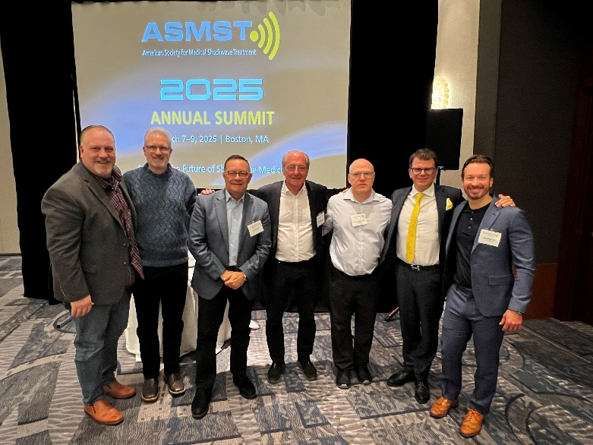

PHOTO CAPTION: Pulse PEMF showcases its cutting-edge pulsed electromagnetic field therapy technology at the ASMST Annual Summit, giving attendees hands-on experience with innovative solutions designed to enhance recovery, reduce pain, and complement shockwave therapy in regenerative medicine.

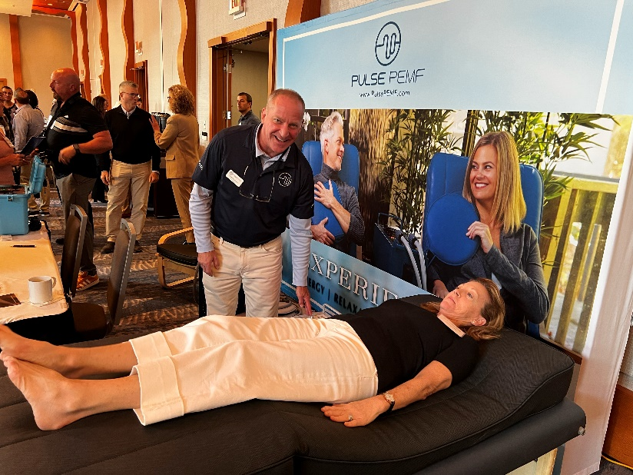

PHOTO CAPTION: Attendees explore the latest advancements in shockwave technology at the ASMST Annual Summit, engaging with state-of-the-art equipment and learning firsthand how innovations are shaping the future of regenerative medicine and patient care.
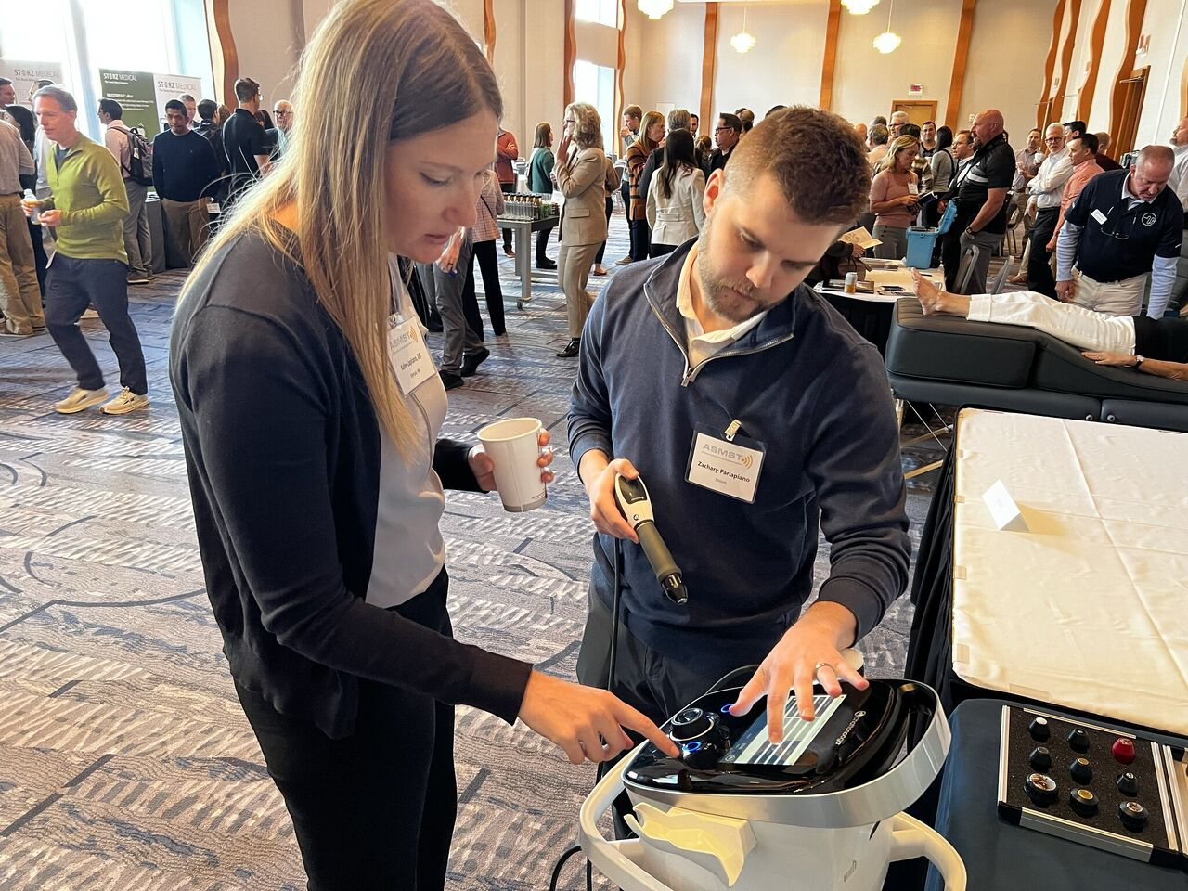

About ASMST:
The American Society for Medical Shockwave Treatment (ASMST) is a nonprofit organization and the premier resource for shockwave knowledge and professional enrichment. Established to advance the understanding and application of evidence-based shockwave medicine, ASMST offers educational programs, research opportunities, and a collaborative community for medical professionals dedicated to this innovative treatment modality. For more information about ASMST, visit www.asmst.org.

###

